Dominic Cwalinski

GEOG 576

Mid Term Project

Tag Sale Locator Application

**Abstract:**

The “Tag Sale Locator” is a web-based application aimed at streamlining the process of finding and sharing information about tag sales within the state of Connecticut. Tag sales, also known as garage or estate sales, are events where individuals sell their possessions at significantly reduced prices. These sales not only facilitate economic transactions but also promote community bonding and contribute to the reduction of unnecessary waste by giving a second life to used items.

However, one of the main challenges associated with tag sales is the lack of a centralized repository for information. Currently, information about these sales is scattered across various platforms such as social media and physical posters, which are often ineffective in reaching a wider audience. This application seeks to address this gap by providing a unified platform where users can both publish and access information on tag sales in their vicinity.

Upon accessing the application, users will find an interactive map displaying the state of Connecticut, with markers indicating the locations of current and upcoming tag sales. Each marker is enriched with information such as the type of sale, operating hours, and contact information, all of which are submitted by the users themselves.

To submit information on a tag sale, users can click on a designated button that opens a Survey123 form. This form enables users to precisely mark the location of the tag sale on the map and input relevant information such as whether they are hosting the sale or sharing details of a sale. The collected data will be stored in a database built on ArcGIS Online, which will also allow for subsequent updates and queries.

The “Tag Sale Locator” is beneficial to both sellers and buyers. Sellers can effortlessly reach a larger audience by posting information about their tag sales, while buyers can conveniently find sales in their vicinity and make informed decisions based on the provided details. Moreover, the application fosters a sense of community by enabling the sharing of local information in a centralized platform. The “Tag Sale Locator” is an innovative, user-friendly, and efficient web application that revolutionizes how information on tag sales is shared and accessed in Connecticut, thus bringing communities closer while promoting sustainable consumption.

**Wireframes:**

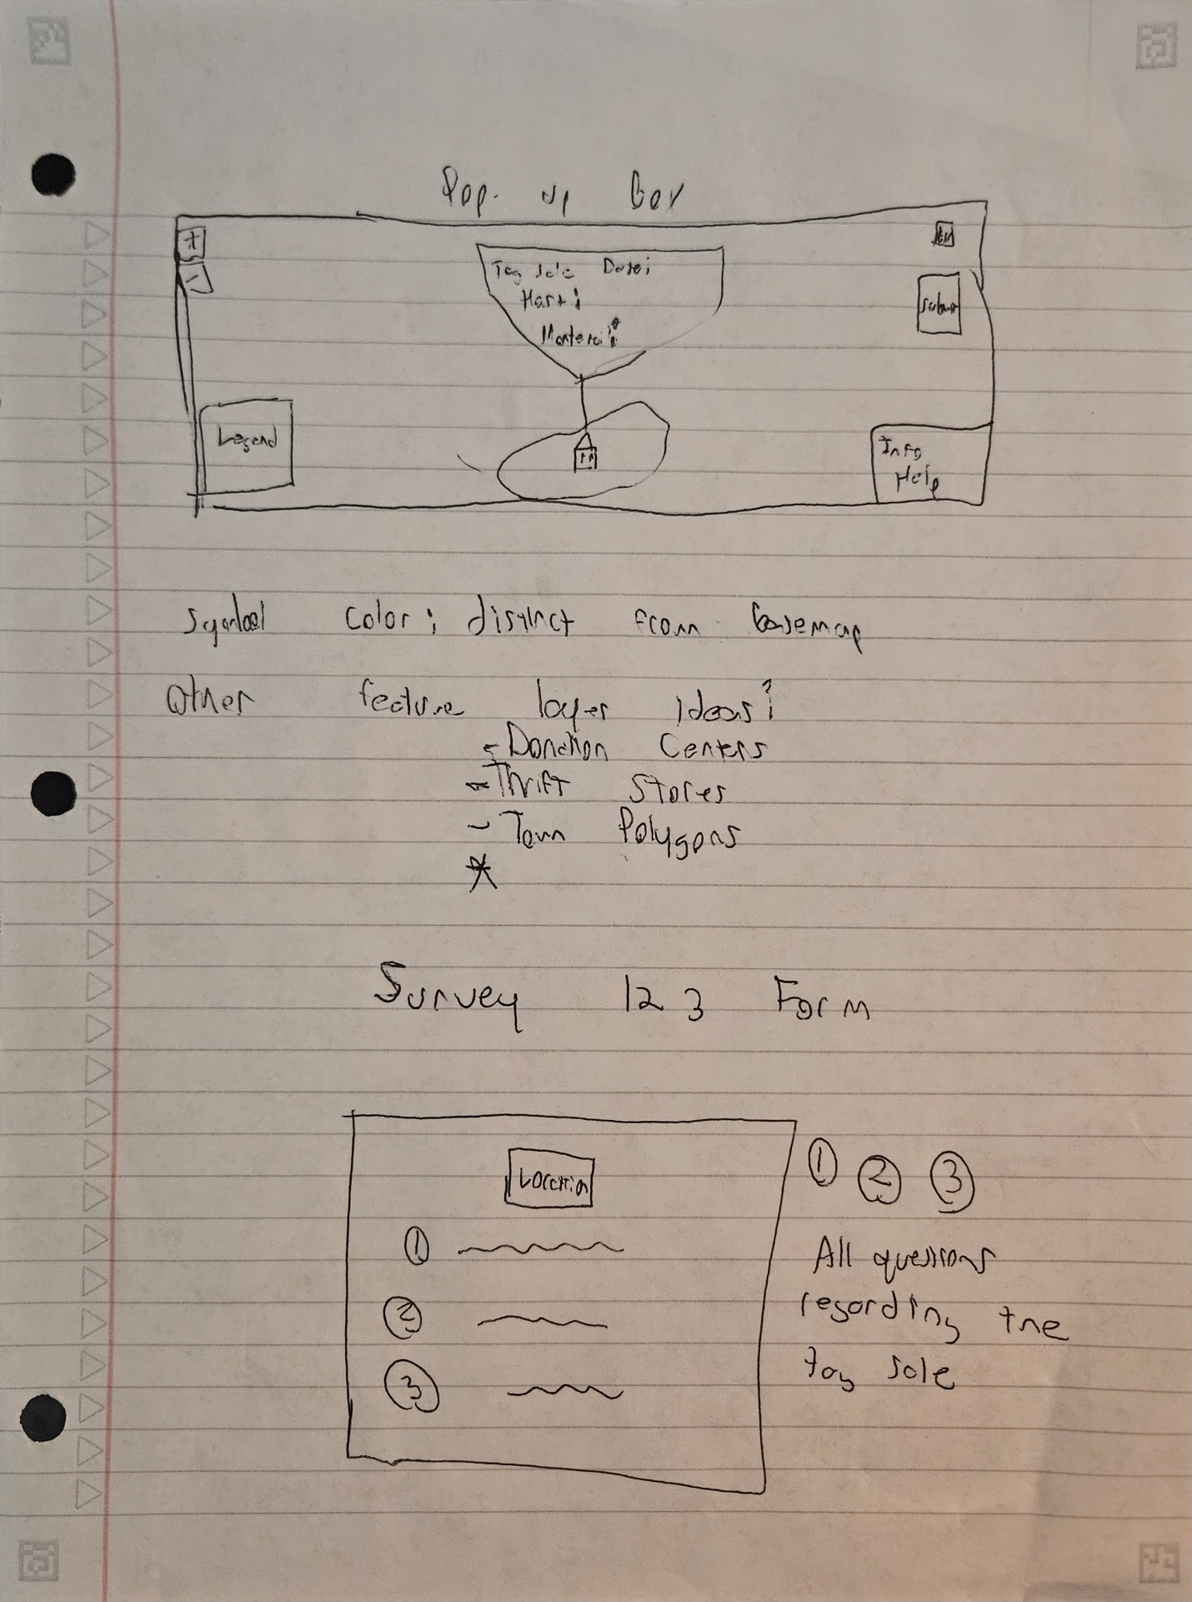

**Data Table:**

|  |  |  |
| --- | --- | --- |
| Data Used | Source | Purpose |
| Esri Basemaps:  Topography,  Imagery,  Imagery Hybrid,  OSM,  Streets,  Navigation | <https://www.arcgis.com/home/item.html?id=67372ff42cd145319639a99152b15bc3>  <https://www.arcgis.com/home/item.html?id=52bdc7ab7fb044d98add148764eaa30a>  <https://www.arcgis.com/home/item.html?id=28f49811a6974659988fd279de5ce39f>  <https://www.arcgis.com/home/item.html?id=c50de463235e4161b206d000587af18b>  <https://www.arcgis.com/home/item.html?id=b834a68d7a484c5fb473d4ba90d35e71>  <https://www.arcgis.com/home/item.html?id=55ebf90799fa4a3fa57562700a68c405> | These are the appropriate base maps that will be used in the application. The user will be able to select what meets his best eye. I believe the Imagery Hybrid or Streets will be the default. |
| CT Town Boundaries | <https://services1.arcgis.com/FjPcSmEFuDYlIdKC/arcgis/rest/services/Connecticut_and_Vicinity_Town_Boundary_Set/FeatureServer> | Service that shows the different towns in Connecticut. Default on for locational purposes. |
| Tag Sale Data | <https://services.arcgis.com/HRPe58bUyBqyyiCt/arcgis/rest/services/survey123_453b28a5c1164c4db099d02150f858f9_results/FeatureServer> | Locational Data of the tag sales created by users Survey123 Form |
| Donation Businesses | <https://services5.arcgis.com/pdfXHSYV8F56tWCx/arcgis/rest/services/USA_DGR_Operators/FeatureServer> | Other thrift/donation centers that could be of interest to the typical tag sale seller/buyer |
| Goodwill Locations US | [**https://services.arcgis.com/HRPe58bUyBqyyiCt/arcgis/rest/services/USA_Goodwill_Locations/FeatureServer**](https://services.arcgis.com/HRPe58bUyBqyyiCt/arcgis/rest/services/USA_Goodwill_Locations/FeatureServer) | Goodwill Donation Centers in the US |

**ER Diagram:**